Bug 2: Incorrect Fine Amount Levied

**Description:**

When a fine is incurred, the amount of fine reported is half the amount intended

**Menu:**

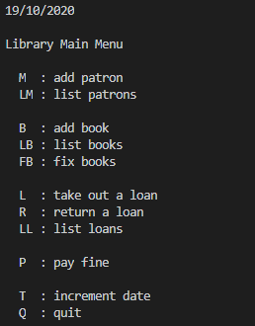

**Inputs:**

**Purpose:** Book Creation

|  |  |
| --- | --- |
| **Prompt** | **Input** |
| Choice : | b |
| Enter author: | Robert Muchamore |
| Enter Title: | The Recruit |
| Enter call number: | 911 |

**Outcome:** Book Created Successfully;

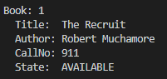

**Purpose:** Patron Creation

|  |  |
| --- | --- |
| **Prompt** | **Input** |
| Choice : | m |
| Enter last name: | Nyberg |
| Enter first name: | Cameron |
| Enter email: | test@test.com |
| Enter phone number: | 911 |

**Outcome:** Patron Created Successfully;

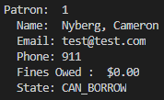

**Purpose:** Borrow Book

|  |  |
| --- | --- |
| **Prompt** | **Input** |
| Choice : | l |
| Swipe patron card (press <enter> to cancel): | 1 |
| Scan Book (<enter> completes): | 1 |
| Scan Book (<enter> completes): | ENTER |
| Commit loans? (Y/N): | y |

**Outcome:** Book Borrowed Successfully;

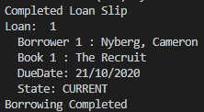

**Purpose:** Showing Fine

**Note:** An ‘increment date’ (of three days) is required, in order to meet the use case of a book overdue by one day.

|  |  |  |
| --- | --- | --- |
| **Prompt** | **Input** | **Outcome** |
| Choice : | t | Increment days selected |
| Enter number of days: | 3 | Date incremented by 3 |
| Choice : | r | Return a loan selected |
| Scan Book (<enter> completes): | 1 | Book 1 selected, with an OVER_DATE associated with the attached Loan |

**Outcome:** Overdue book returned, identified as overdue and fine is associated.

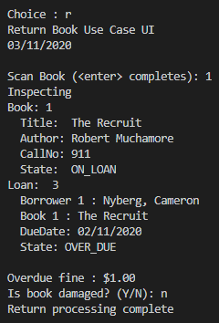

**Purpose:** Bug Identification

**Note:** The displayed fine, versus the actual fine (in pay fine), is half

|  |  |  |
| --- | --- | --- |
| **Prompt** | **Input** | **Outcome** |
| Choice : | P | Pay fine |
| Swipe patron card (press <enter> to cancel): | 1 | Select patron |

**Outcome:** Fines owed is double what we expected

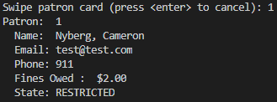

**Simplification**

Replicated by essentially executing the same code as Bug 1 but this time noting that running the UI output method.. output() actually displays the current, standing overdue fine for the patron

Sample Output:

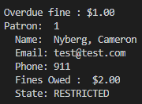

**Tracing**

Checking PayFineUI, we can determine that the output of the Fine display, is given by the object itself (Patron) – payFineUi.display(patron);

The following method, allows us to identify a familiar field “Fines Owed”

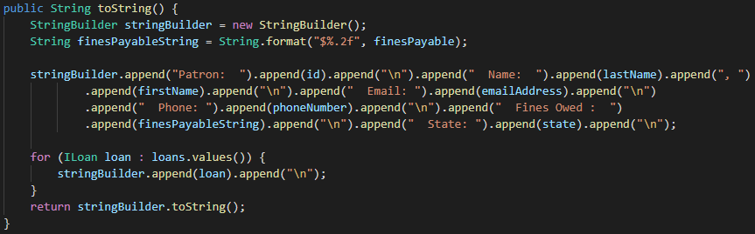

From here, we can identify finesPayable

Tracing that back to where it comes from, we can observe this value is only modified upon creation, or when the incurFine method is called; the additional fines aren’t being added.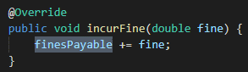

Given that there are no fines that are halved, or anything of that nature – making the determination that the corrective action, is to simply determine this bug as purely visual and correct, during the display of the actual fine.

Checking where ‘Overdue fine’ is displayed – ReturnBookControl

Multiplying the output variable by 2 and now noting that the Simplification test, displays a 1:1 output of the fines.

